MINISTRY OF EDUCATION AND SCIENCE OF THE REPUBLIC OF KAZAKHSTAN

INTERNATIONAL INFORMATION TECHNOLOGY UNIVERSITY

FACULTY OF INFORMATION TECHNOLOGIES

Department of Computer engineering and information security

COURSE PROJECT

Major 6B06110 – Software engineering

Discipline Web technologies

Topic: _______________Pharmacy_______________________

|  |  |  |
| --- | --- | --- |
| STUDENT(S): | ITSE-1906  Kabyl Dauren  (group and student name) | _____________  (signature) |
| SUPERVISOR: | Assistant-professor  Mukazhanov N.K.  (position, name) | _____________  (signature) |

Almaty 2021

# **Content**

Introduction___________________________________________________3

Main part_____________________________________________________4

* Theoretical part__________________________________________4
* Design_________________________________________________5
* Implementation (creation of website)_________________________7

Conclusion___________________________________________________10

References___________________________________________________11

# **Introduction**

My project is a pharmacy website where visitors can order medicines, get health advice, or contact us for help finding medicines.

The website Interface is based on HTML, CSS, Bootstrap.

The website Back-end is based on Python Django.

The used server is PostgreSQL.

Link to github repository:

<https://github.com/diikiin/Web-project>

**Main part**

***Theoretical part***

**HyperText Markup Language** (HTML) is the set of markup symbols or codes inserted into a file intended for display on the Internet. The markup tells web browsers how to display a web page's words and images.

Each individual piece markup code (which would fall between "<" and ">" characters) is referred to as an element, though many people also refer to it as a tag. Some elements come in pairs that indicate when some display effect is to begin and when it is to end.

* HyperText Markup Language (HTML) is the basic scripting language used by web browsers to render pages on the world wide web.
* HyperText allows a user to click a link and be redirected to a new page referenced by that link.
* Early versions of HTML were static, while newer iterations feature a great deal of dynamic flexibility.
* Markup is the text that appears between two pointed brackets (e.g., <footnote>), and content is everything else.

**Cascading Style Sheets**, fondly referred to as CSS, is a simple design language intended to simplify the process of making web pages presentable.

CSS handles the look and feel part of a web page. Using CSS, you can control the color of the text, the style of fonts, the spacing between paragraphs, how columns are sized and laid out, what background images or colors are used, layout designs, variations in display for different devices and screen sizes as well as a variety of other effects.

**Bootstrap** is a powerful toolkit - a collection of HTML, CSS, and JavaScript tools for creating and building web pages and web applications. It is a free and opensource project, hosted on GitHub, and originally created by (and for) Twitter.

***Design:***

The Model-View-Controller (MVC) is an architectural pattern that separates an application into three main logical components: the model, the view, and the controller. Each of these components are built to handle specific development aspects of an application. MVC is one of the most frequently used industry-standard web development framework to create scalable and extensible projects.

The Model component corresponds to all the data-related logic that the user works with. This can represent either the data that is being transferred between the View and Controller components or any other business logic-related data. For example, a Customer object will retrieve the customer information from the database, manipulate it and update it data back to the database or use it to render data.

The View component is used for all the UI logic of the application. For example, the Customer view will include all the UI components such as text boxes, dropdowns, etc. that the final user interacts with.

Controllers act as an interface between Model and View components to process all the business logic and incoming requests, manipulate data using the Model component and interact with the Views to render the final output. For example, the Customer controller will handle all the interactions and inputs from the Customer View and update the database using the Customer Model. The same controller will be used to view the Customer data.

***Implementation (creation of website):***

Home page

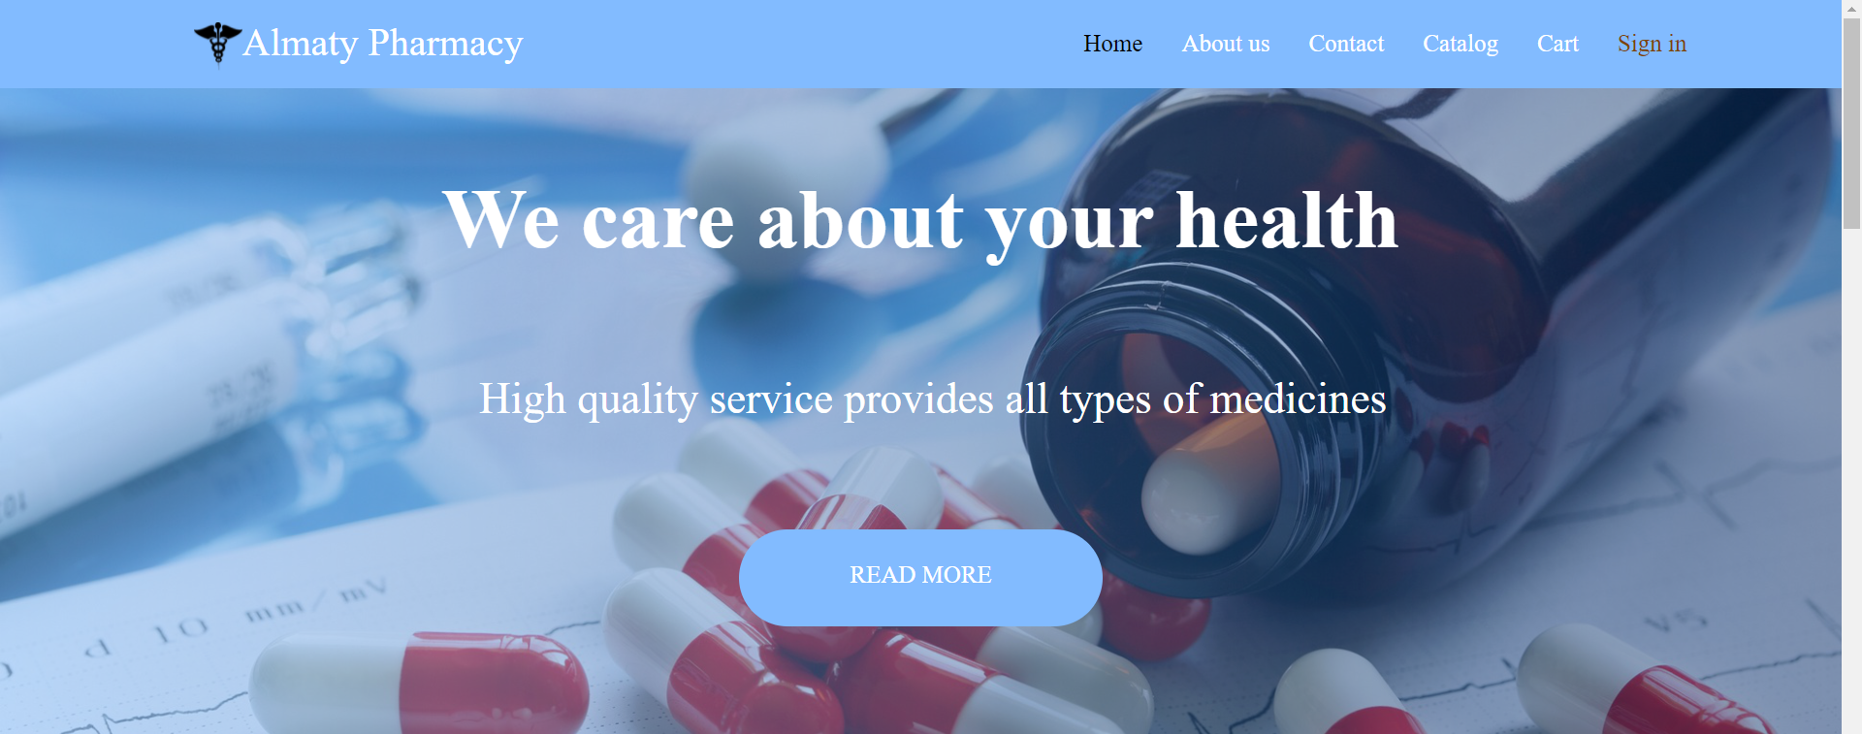

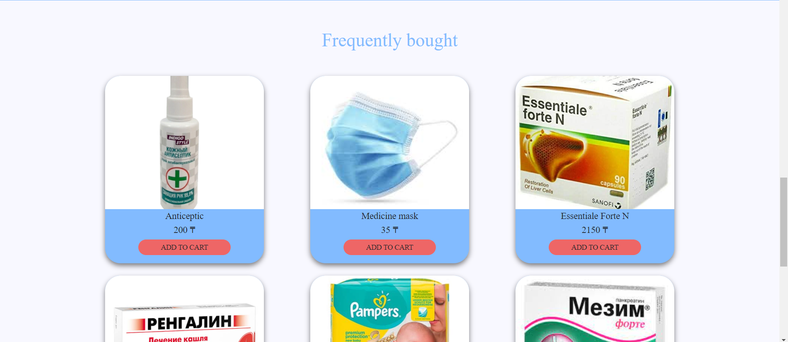

Contact page

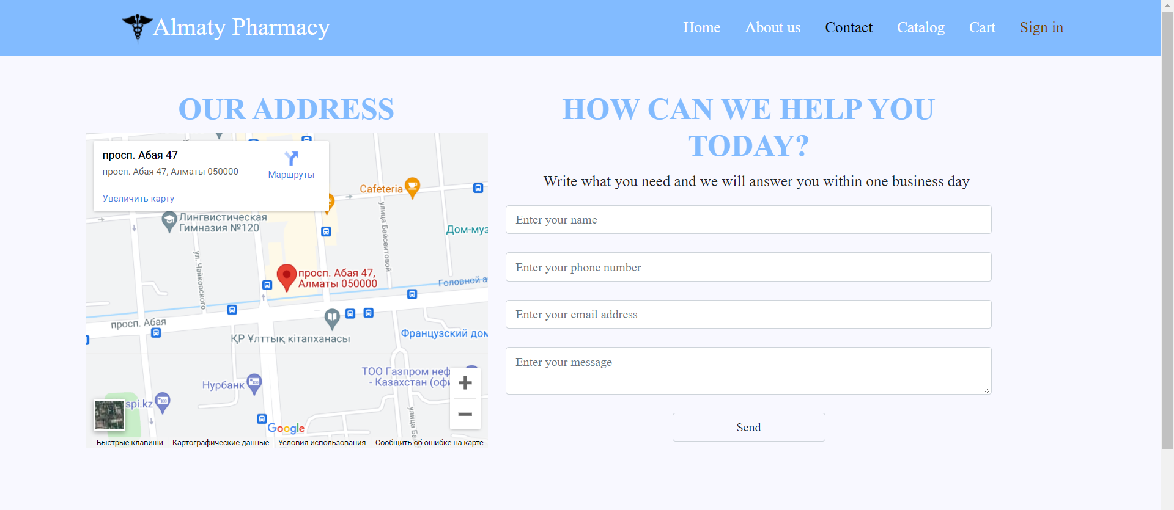

About page

Login page

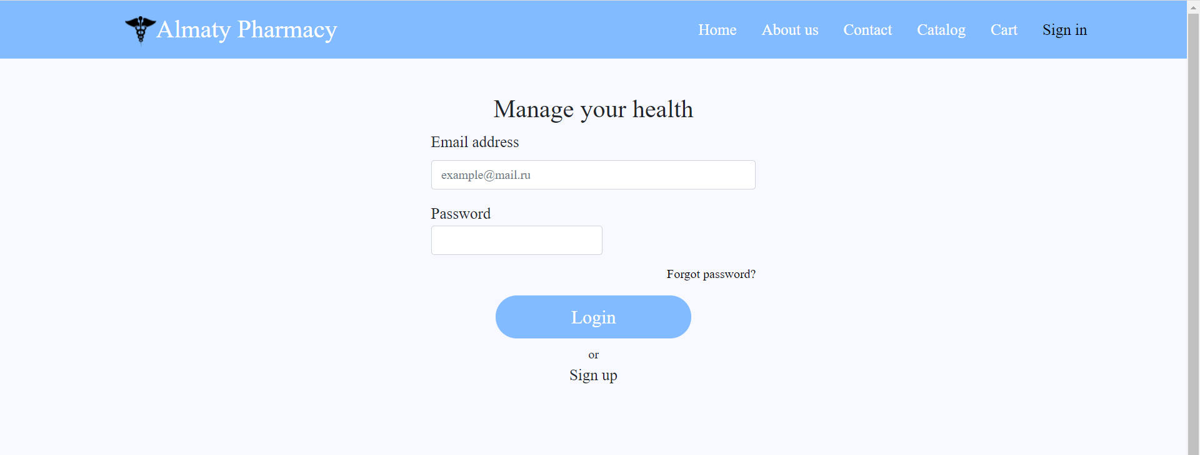

Registration page



Cart page



**Conclusion**

The Pharmacy features:

* Login/Registration
* The opportunity will receive health advice.
* View the catalog of drugs.
* Purchase of medicines and delivery.

**References**

1. <https://www.yourhtmlsource.com/starthere/whatishtml.html>
2. <https://www.w3schools.com/css/css_intro.asp>
3. <https://www.toptal.com/front-end/what-is-bootstrap-a-short-tutorial-on-the-what-why-and-how>
4. <https://nicepage.com/html5-template/preview/pharmacy-and-medicine-16713?device=desktop>
5. <https://centralpharmacync.com/>
6. <https://lloydspharmacy.com/>
7. <https://www.walgreens.com/>